|  |  |  |
| --- | --- | --- |
| Nama | : | Nur Syifa Maulida |
| NIM | : | 1207070088 |
| MatKul | : | PCD |

1. Filter Laplacian

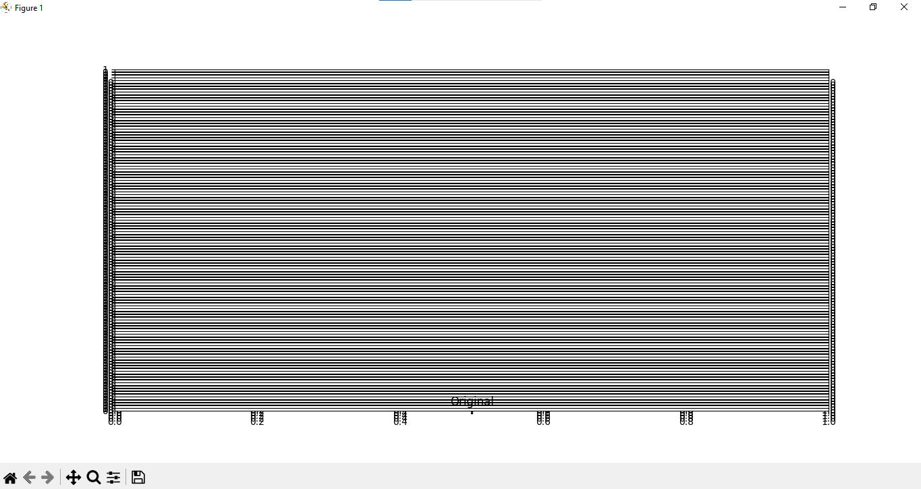

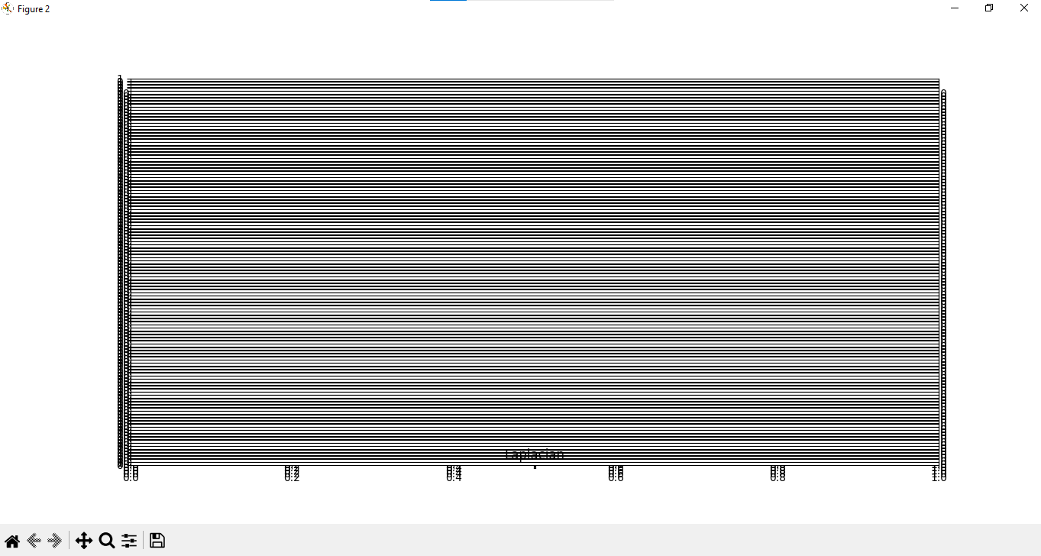

1. Rotation

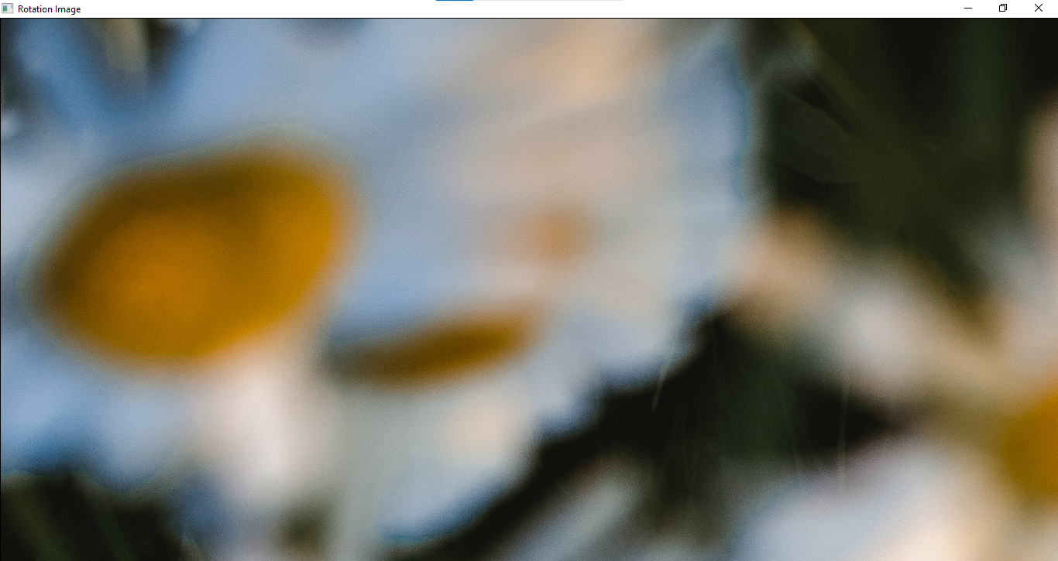

1. Filter Canny

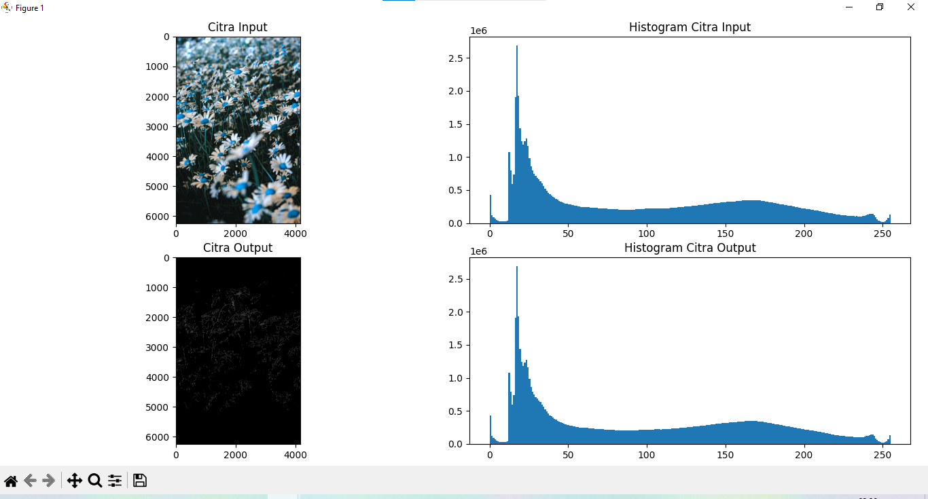

1. Filter Sobel

